Northern India Engineering College, Shastri Park, New Delhi

**Department of Information Technology**

**Notes for Second Term Exam**

**Fundamentals of Computing (Code ETCS – 111)**

**Course Facilitator: Dr Shafiq ul Abidin, HoD – IT**

**What is OS?**

An operating system (OS) is a collection of software that manages [computer hardware](http://en.wikipedia.org/wiki/Computer_hardware) resources and provides common [services](http://en.wikipedia.org/wiki/Operating_system_services) for [computer programs](http://en.wikipedia.org/wiki/Computer_program). The operating system is an essential component of the [system software](http://en.wikipedia.org/wiki/System_software) in a computer system. Application programs usually require an operating system to function.

There are two types of OS

***Single User Operating System*** (Example - DOS, MSDOS, CP/M and earlier versions of Mac)

***Multiuser Operating System*** (Examples - Windows 2000, Windows XP, Unix, Linux)

***Types of Operating Systems:***

***Real-time***

A [real-time operating system](http://en.wikipedia.org/wiki/Real-time_operating_system) is a multitasking operating system that aims at executing real-time applications. Real-time operating systems often use specialized scheduling algorithms so that they can achieve a deterministic nature of behavior. The main objective of real-time operating systems is their quick and predictable response to events. They have an event-driven or time-sharing design and often aspects of both. An event-driven system switches between tasks based on their priorities or external events while time-sharing operating systems switch tasks based on clock interrupts.

***Multi-user***

A [multi-user](http://en.wikipedia.org/wiki/Multi-user) operating system allows multiple users to access a computer system at the same time. Time-sharing systems and Internet servers can be classified as multi-user systems as they enable multiple-user access to a computer through the sharing of time. Single-user operating systems have only one user but may allow multiple programs to run at the same time.

***Multi-tasking vs. single-tasking***

A [multi-tasking](http://en.wikipedia.org/wiki/Multi-tasking) operating system allows more than one program to be running at the same time, from the point of view of human time scales. A single-tasking system has only one running program. Multi-tasking can be of two types: pre-emptive and co-operative. In pre-emptive multitasking, the operating system slices the CPU time and dedicates one slot to each of the programs. Unix-like operating systems such as Solaris and Linux support pre-emptive multitasking, as does [AmigaOS](http://en.wikipedia.org/wiki/AmigaOS). Cooperative multitasking is achieved by relying on each process to give time to the other processes in a defined manner. [16-bit](http://en.wikipedia.org/wiki/16-bit) versions of Microsoft Windows used cooperative multi-tasking. [32-bit](http://en.wikipedia.org/wiki/32-bit) versions of both Windows NT and Win9x, used pre-emptive multi-tasking. Mac OS prior to OS X used to support cooperative multitasking.

***Distributed***

Further information: [Distributed system](http://en.wikipedia.org/wiki/Distributed_system)

A distributed operating system manages a group of independent computers and makes them appear to be a single computer. The development of networked computers that could be linked and communicate with each other gave rise to distributed computing. Distributed computations are carried out on more than one machine. When computers in a group work in cooperation, they make a distributed system.

***Embedded***

[Embedded operating systems](http://en.wikipedia.org/wiki/Embedded_operating_system) are designed to be used in [embedded computer systems](http://en.wikipedia.org/wiki/Embedded_system). They are designed to operate on small machines like PDAs with less autonomy. They are able to operate with a limited number of resources. They are very compact and extremely efficient by design. Windows CE and Minix 3 are some examples of embedded operating systems.

**Windows 2000**

Windows 2000 (W2K) is a est commercial version of Microsoft's evolving Windows [operating system](http://searchcio-midmarket.techtarget.com/definition/operating-system). Previously called [Windows NT](http://searchwinit.techtarget.com/definition/Windows-NT) 5.0, Microsoft emphasizes that Windows 2000 is evolutionary and "Built on NT Technology." Windows 2000 is designed to appeal to small business and professional users as well as to the more technical and larger business market for which the NT was designed.

The Windows 2000 product line consists of four products:

Windows 2000 Professional, aimed at individuals and businesses of all sizes. It includes security and mobile use enhancements. It is the most economical choice.

Windows 2000 Server, aimed at small-to-medium size businesses. It can function as a Web server and/or a workgroup (or branch office) server. It can be part of a two-way symmetric multiprocessing system. NT 4.0 servers can be upgraded to this server.

Windows 2000 Advanced Server, aimed at being a network operating system server and/or an application server, including those involving large [database](http://searchsqlserver.techtarget.com/definition/database)s. This server facilitates clustering and load-balancing. NT 4.0 servers with up to eight-way SMP can upgrade to this product.

Windows 2000 Datacenter Server, designed for large [data warehouse](http://searchsqlserver.techtarget.com/definition/data-warehouse)s, online transaction processing ([OLTP](http://searchdatacenter.techtarget.com/definition/OLTP)), econometric analysis, and other applications requiring high-speed computation and large databases. The Datacenter Server supports up to 16-way SMP and up to 64 gigabytes of physical memory.

Windows 2000 is reported to be more stable (less apt to crash) than Windows 98/NT systems. A significant new feature is Microsoft's [Active Directory](http://searchwindowsserver.techtarget.com/definition/Active-Directory), which, among other capabilities, enables a company to set up [virtual private network](http://searchenterprisewan.techtarget.com/definition/virtual-private-network)s, to encrypt data locally or on the network, and to give users access to shared files in a consistent way from any network computer.

**Windows 2000 and Windows NT**

Windows NT 4.0 and Windows 2000 are two operating systems created by Microsoft and marketed for business users. The two operating systems were released several years apart: Windows NT 4.0 in 1996, and Windows 2000 in 2000. Owing in part to the significant amount of time that passed between the releases of the two operating systems, Windows 2000 has several features that Windows NT 4.0 does not.

**Windows Administrative Tools**

***Task Scheduler***

The Task Scheduler enables you to automatically perform routine tasks on a chosen computer. The Task Scheduler does this by monitoring whatever criteria you choose to initiate the tasks

***Component Services***

Component Services. Configure and administer Component Object Model (COM) components. Component Services is designed for use by developers and administrators.

***Event Viewer***

Event Viewer. View information about significant events, such as a program starting or stopping, or a security error, which are recorded in event logs.

***Print Management***

Print Management. Manage printers and print servers on a network and perform other administrative tasks.

***Local Security***

Windows Firewall with Advanced Security. Configure advanced firewall settings on both this computer and remote computers on your network.

***System Configuration***

System Configuration. Identify problems that might be preventing Windows from running correctly.

**Windows Utilities**

***Paint***

***WordPad***

***Calculator***

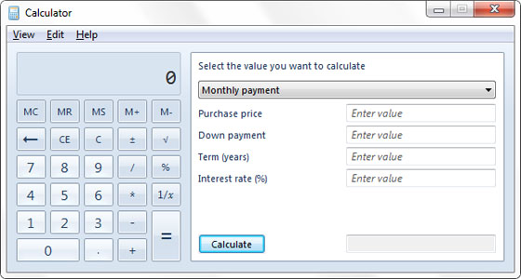

Calculator picks up a bunch of new functionality, including this handy mortgage calculator.

***Windows 7 also includes a Sticky Notes application.***

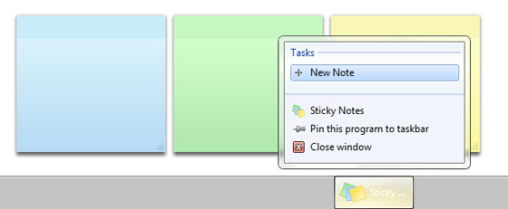

***Windows Calendar***

***Windows DVD Maker***

***Windows Media Player***

***Windows Fax and Scan***

***Microsoft Safety Scanner***

Help protect your PC and remove malicious software (including Blaster, Sasser, and Mydoom).   
***Windows Live Movie Maker 2011***

Craft video footage, photos, and music into a movie, then share it with your friends.   
***Skype for Windows***

Keep in touch with the people you care about most. Video Call or Chat, Skype helps you get together.

***Windows 7 USB DVD Download Tool***

Allows you to install a downloaded copy of Windows 7 onto your computer directly from the USB flash drive or DVD.

***Microsoft Touch Pack for Windows 7***

A collection of games and applications for your Windows touch-enabled PC, including Blackboard, Surface Globe, and Collage.

***Windows System Registry***

The Windows Registry is a hierarchical database that stores configuration settings and options on Microsoft Windows operating systems. It contains settings for low-level operating system components and for applications running on the platform that have opted to use the registry. ...

**Overview of Linux OS**

**The Birth of Linux**

On August 25, 1991, a Finn computer science student named Linus Torvalds made the following announcement to the Usenet group comp.os.minux:

**What is Linux?**

Linux is, in simplest terms, an operating system. It is the software on a computer that enables applications and the computer operator to access the devices on the computer to perform desired functions. The operating system (OS) relays instructions from an application to, for instance, the computer's processor. The processor performs the instructed task, then sends the results back to the application via the operating system.

Explained in these terms, Linux is very similar to other operating systems, such as Windows and OS X.

But something sets Linux apart from these operating systems. The Linux operating system represented a $25 billion ecosystem in 2008. Since its inception in 1991, Linux has grown to become a force in computing, powering everything from the New York Stock Exchange to mobile phones to supercomputers to consumer devices.

As an open operating system, Linux is developed collaboratively, meaning no one company is solely responsible for its development or ongoing support. Companies participating in the Linux economy share research and development costs with their partners and competitors. This spreading of development burden amongst individuals and companies has resulted in a large and efficient ecosystem and unheralded software innovation.

Over 1,000 developers, from at least 100 different companies, contribute to every kernel release. In the past two years alone, over 3,200 developers from 200 companies have contributed to the kernel--which is just one small piece of a Linux distribution.

This article will explore the various components of the Linux operating system, how they are created and work together, the communities of Linux, and Linux's incredible impact on the IT ecosystem.

**Where is Linux?**

One of the most noted properties of Linux is where it can be used. Windows and OS X are predominantly found on personal computing devices such as desktop and laptop computers. Other operating systems, such as Symbian, are found on small devices such as phones and PDAs, while mainframes and supercomputers found in major academic and corporate labs use specialized operating systems such as AS/400 and the Cray OS.

Linux, which began its existence as a server OS and Has become useful as a desktop OS, can also be used on all of these devices.

Linux is already successful on many different kinds of devices, but there are also many technological areas where Linux is moving towards, even as desktop and server development continues to grow faster than any other operating system today.

**Linux Architecture**

Linux System Architecture is consists of following layers

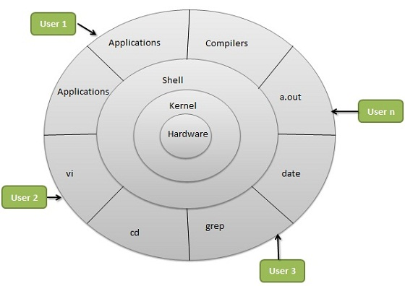

* **Hardware layer** - Hardware consists of all peripheral devices (RAM/ HDD/ CPU etc).
* **Kernel** - Core component of Operating System, interacts directly with hardware, provides low level services to upper layer components.
* **Shell** - An interface to kernel, hiding complexity of kernel's functions from users. Takes commands from user and executes kernel's functions.
* **Utilities** - Utility programs giving user most of the functionalities of an operating systems.

**Components of Linux System**

Linux Operating System has primarily three components

* **Kernel** - Kernel is the core part of Linux. It is responsible for all major activities of this operating system. It is consists of various modules and it interacts directly with the underlying hardware. Kernel provides the required abstraction to hide low level hardware details to system or application programs.
* **System Library** - System libraries are special functions or programs using which application programs or system utilities accesses Kernel's features. These libraries implements most of the functionalities of the operating system and do not requires kernel module's code access rights.
* **System Utility** - System Utility programs are responsible to do specialized, individual level tasks.

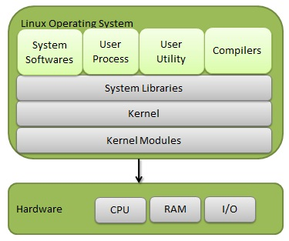

**Linux File Structure**

In Linux all files organized into directories and directories are connected through the hierarchical order. The Linux file structure branches into several directories beginning with a root ( / ) directory.

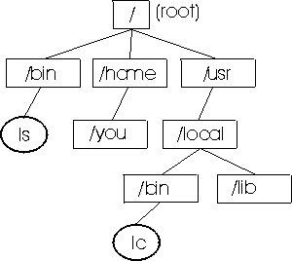

**root**  - The root directory presents in all file system structure is the ancestor of all files in the file system.

**bin** – It holds the essential command and binaries files needed to run the system in single user mode.

**home** - It holds all the directories/ subdirectories of users.

**usr** – contains user applications and supporting files.

**File Permission in Linux**

In Linux, a file may have read, write and execute permission. When a file is created then it is automatically given read and write permission for the owner.

There are three categories of users who can have access to a file or directory.

***Owner***

***Group***

***Others***

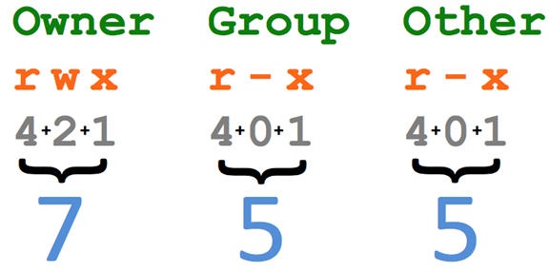

Permissions is granted by using a set of octal number program. Each authorization is associated to a number:

Read( r) = 4  
Write (w) = 2  
Execute ( x) = 1

Each category has its own set of read, write and execute permission for example

**- r w x r w x r w x**

Owner Group Others

First dash shows file types whereas first set of rwx is for owner, second set of rwx for group and third set of rwx for others.

***Command for File Permission***

Change Mode Command is used to change the permission.

chmod

**chmod 777 myfile**

This command sets the r/w/x permissions for all (owner, group and others).

**chmod 766 filename**

This command sets r/w/x permissions for owner and r/w permissions for group and others.

**RPM Package Manager**

Red Hat Package Manager or RPM Package Manager (RPM) is a [package management system](http://en.wikipedia.org/wiki/Package_management_system). The name RPM variously refers to the .rpm [file format](http://en.wikipedia.org/wiki/File_format), files in this format, [software](http://en.wikipedia.org/wiki/Software) packaged in such files, and the package manager itself. RPM was intended primarily for [Linux distributions](http://en.wikipedia.org/wiki/Linux_distribution); the file format is the baseline package format of the [Linux Standard Base](http://en.wikipedia.org/wiki/Linux_Standard_Base).

RPM was originally written in 1997 by Erik Troan and Marc Ewing, based on pms, rpp, and pm experiences.

**Deb Packages**

Debian packages are standard [Unix](http://en.wikipedia.org/wiki/Unix)/Linux archieves that include two [tar](http://en.wikipedia.org/wiki/Tar_%28file_format%29) archives optionally compressed with [gzip](http://en.wikipedia.org/wiki/Gzip) (zlib), [Bzip2](http://en.wikipedia.org/wiki/Bzip2), [lzma](http://en.wikipedia.org/wiki/Lzma), or [xz](http://en.wikipedia.org/wiki/Xz) (lzma2): one archive holds the control information and another contains the program data.

Debian packages can be converted into other packages and vice versa using [alien](http://en.wikipedia.org/wiki/Alien_%28software%29), and created from source code using [CheckInstall](http://en.wikipedia.org/wiki/CheckInstall) or Debian Package Maker.

**Computer Network**

A network consists of two or more computers that are linked in order to share resources (such as printers and CDs), exchange files, or allow

electronic communications.

The computers on a network may be linked through cables, telephone lines, radio waves, satellites, or infrared light beams.

A computer network or data network is a [telecommunications network](http://en.wikipedia.org/wiki/Telecommunications_network) that allows [computers](http://en.wikipedia.org/wiki/Computer) to exchange [data](http://en.wikipedia.org/wiki/Data_%28computing%29). In computer networks, networked computing devices ([network nodes](http://en.wikipedia.org/wiki/Node_%28networking%29)) pass data to each other along data connections. The connections ([network links](http://en.wikipedia.org/wiki/Data_link)) between nodes are established using either [cable media](http://en.wikipedia.org/wiki/Transmission_line) or [wireless media](http://en.wikipedia.org/wiki/Wireless_network). The best-known computer network is the [Internet](http://en.wikipedia.org/wiki/Internet).

Network devices that originate, route and terminate the data are called [network nodes](http://en.wikipedia.org/wiki/Node_%28networking%29).[[1]](http://en.wikipedia.org/wiki/Computer_network#cite_note-1) Nodes can include [hosts](http://en.wikipedia.org/wiki/Host_%28network%29) such as [servers](http://en.wikipedia.org/wiki/Server_%28computing%29) and [personal computers](http://en.wikipedia.org/wiki/Personal_computer), as well as [networking hardware](http://en.wikipedia.org/wiki/Networking_hardware). Two devices are said to be networked when a device is able to exchange information with another device.

Computer networks support [applications](http://en.wikipedia.org/wiki/Application_software) such as access to the [World Wide Web](http://en.wikipedia.org/wiki/World_Wide_Web), shared use of [application and storage servers](http://en.wikipedia.org/wiki/File_server), [printers](http://en.wikipedia.org/wiki/Printing), and fax machines, and use of [email](http://en.wikipedia.org/wiki/Email) and [instant messaging](http://en.wikipedia.org/wiki/Instant_messaging) applications. Computer networks differ in the physical media used to transmit their signals, the [communications protocols](http://en.wikipedia.org/wiki/Communications_protocol) to organize network traffic, the network's size, [topology](http://en.wikipedia.org/wiki/Network_topology) and organizational intent.

***Types of Networks***

There are different types of **computer networks**. Some of the common ones include;

1. Local Area Network LAN – These types of **computer networks** connect network devices over a relatively short distance. Quite often, a networked office building, home or school contains a single LAN although it is normal to come across a building that contains a few small LANs. On a few occasions, a LAN may also span over a group of nearby buildings. Such **computer networks** are usually owned by one organisation.
2. Wide Area Network WAN – As the name suggests, a WAN spans over a large physical distance. It may be regarded as a collection of LANs dispersed over a geographical area. The internet is a very good example of a WAN. LANs are connected to a WAN through a device referred to as a router. In IP networking, both the LAN and WAN addresses are maintained by the router. Most WANs exist under distributed or collective ownership and management and unlike the LANs, are not necessarily owned by one organisation.
3. Metropolitan Area Network MAN – This is a network that spans over a physical area like a city that is smaller than a WAN but larger than a LAN. Quite often, such **computer networks** are owned and operated by single entities such as government bodies or large corporations.

**Network Topologies**

The [mesh network](http://searchnetworking.techtarget.com/definition/mesh-network) topology employs either of two schemes, called full mesh and partial mesh. In the full mesh topology, each workstation is connected directly to each of the others. In the partial mesh topology, some workstations are connected to all the others, and some are connected only to those other nodes with which they exchange the most data.

The [tree network](http://searchnetworking.techtarget.com/definition/tree-network) topology uses two or more star networks connected together. The central computers of the star networks are connected to a main bus. Thus, a tree network is a bus network of star networks.

Logical (or signal) topology refers to the nature of the paths the signals follow from node to node. In many instances, the logical topology is the same as the physical topology. But this is not always the case. For example, some networks are physically laid out in a star configuration, but they operate logically as bus or ring networks.

The following sections discuss the physical topologies used in networks and other related topics.

* [Linear Bus](http://fcit.usf.edu/network/chap5/chap5.htm#LinearBusnetwork)
* [Star](http://fcit.usf.edu/network/chap5/chap5.htm#StarNetwork)
* [Tree (Expanded Star)](http://fcit.usf.edu/network/chap5/chap5.htm#TreeNetwork)
* [Considerations When Choosing a Topology](http://fcit.usf.edu/network/chap5/chap5.htm#Considerations)

***Linear Bus***

A linear bus topology consists of a main run of cable with a terminator at each end (See fig. 1). All nodes (file server, workstations, and peripherals) are connected to the linear cable.

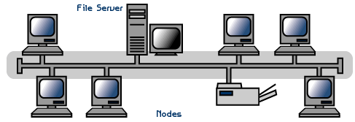

Fig Linear Bus topology

***Advantages of a Linear Bus Topology***

* Easy to connect a computer or peripheral to a linear bus.
* Requires less cable length than a star topology.

***Disadvantages of a Linear Bus Topology***

* Entire network shuts down if there is a break in the main cable.
* Terminators are required at both ends of the backbone cable.
* Difficult to identify the problem if the entire network shuts down.
* Not meant to be used as a stand-alone solution in a large building.

***Star***

A star topology is designed with each node (file server, workstations, and peripherals) connected directly to a central network hub, switch, or concentrator (See fig. 2).

Data on a star network passes through the hub, switch, or concentrator before continuing to its destination. The hub, switch, or concentrator manages and controls all functions of the network. It also acts as a repeater for the data flow. This configuration is common with twisted pair cable; however, it can also be used with coaxial cable or fiber optic cable.

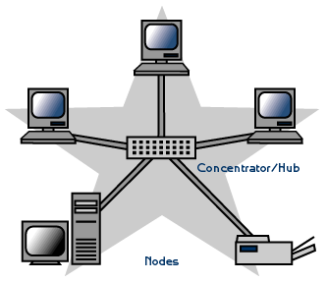

Fig. Star topology

***Advantages of a Star Topology***

* Easy to install and wire.
* No disruptions to the network when connecting or removing devices.
* Easy to detect faults and to remove parts.

***Disadvantages of a Star Topology***

* Requires more cable length than a linear topology.
* If the hub, switch, or concentrator fails, nodes attached are disabled.
* More expensive than linear bus topologies because of the cost of the hubs, etc.

***Tree or Expanded Star***

A tree topology combines characteristics of linear bus and star topologies. It consists of groups of star-configured workstations connected to a linear bus backbone cable (See fig. 3). Tree topologies allow for the expansion of an existing network, and enable schools to configure a network to meet their needs.

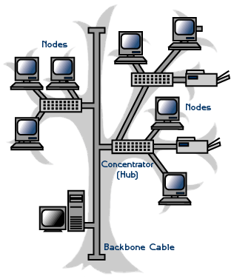

Fig Tree topology

***Advantages of a Tree Topology***

* Point-to-point wiring for individual segments.
* Supported by several hardware and software venders.

***Disadvantages of a Tree Topology***

* Overall length of each segment is limited by the type of cabling used.
* If the backbone line breaks, the entire segment goes down.
* More difficult to configure and wire than other topologies.

***Considerations When Choosing a Topology***

* **Money**. A linear bus network may be the least expensive way to install a network; you do not have to purchase concentrators.
* **Length of cable needed**. The linear bus network uses shorter lengths of cable.
* **Future growth**. With a star topology, expanding a network is easily done by adding another concentrator.
* C**able type**. The most common cable in schools is unshielded twisted pair, which is most often used with star topologies.

**Protocols**

A protocol is a set of rules that governs the communications between computers on a network. In order for two computers to talk to each other, they must be speaking the same language. Many different types of network protocols and standards are required to ensure that your computer (no matter which operating system, network card, or application you are using) can communicate with another computer located on the next desk or half-way around the world. The OSI (Open Systems Interconnection) Reference Model defines seven layers of networking protocols. The complexity of these layers is beyond the scope of this tutorial; however, they can be simplified into four layers to help identify some of the protocols with which you should be familiar

Network protocol - Within computer science, a communications protocol is a system of digital rules for message exchange within or between computers. Communicating systems use well-defined formats for exchanging messages. Each message has an exact meaning intended to provoke a particular response of the receiver.

* ***HTTP-*** HyperText Transfer Protocol - An Internet-based protocol for sending and receiving webpages.

HTTP defines how messages are formatted and transmitted, and what actions [Web servers](http://www.webopedia.com/TERM/W/Web_server.html) and [browsers](http://www.webopedia.com/TERM/B/browser.html) should take in response to various commands. For example, when you enter a [URL](http://www.webopedia.com/TERM/U/URL.html) in your browser, this actually sends an HTTP command to the Web server directing it to fetch and transmit the requested [Web page](http://www.webopedia.com/TERM/W/web_page.html).

* ***HTTPS-*** Hyper Text Transfer Protocol Secure (HTTPS) is a secure version of the Hyper Text Transfer Protocol (http). [HTTPS](http://www.instantssl.com/?key5sk1=d636fdfc2ef33e8a4af279dfecb55ca909793113&key5sk2=&key5sk3=1384231013000&key6sk1=&key6sk2=FF250&key6sk3=7&key6sk4=en-us&key6sk5=GB&key6sk6=0&key6sk7=Google&key6sk8=119900&key6sk9=12801024&key6sk10=false&key6sk11=8e005b6beb04cc7a1fafda93f7e327748f0ab172&key7sk1=16588&key1sk1=ors&key1sk2=Google) allows secure ecommerce transactions, such as online banking.

When a user connects to a website via HTTPS, the website encrypts the session with a Digital Certificate. A user can tell if they are connected to a secure website if the website URL begins with https:// instead of http://.

* ***FTP is*** an acronym for File Transfer Protocol. As the name suggests, FTP is used to transfer files between computers on a network. You can use FTP to exchange files between computer accounts, transfer files between an account and a desktop computer, or access online software archives. Keep in mind, however, that many FTP sites are heavily used and require several attempts before connecting.

FTP is the easiest way to transfer files between computers via the internet, and utilizes TCP, transmission control protocol, and IP, internet protocol, systems to perform uploading and downloading tasks.

* ***SMTP*** stands for Simple Mail Transfer Protocol. It's a set of communication guidelines that allow software to transmit email over the Internet. Most email software is designed to use SMTP for communication purposes when sending email, and It only works for outgoing messages. When people set up their email programs, they will typically have to give the address of their Internet service provider's SMTP server for outgoing mail. There are two other protocols - POP3 and IMAP - that are used for retrieving and storing email.
* ***PPP*** (Point-to-Point Protocol) is a [protocol](http://searchnetworking.techtarget.com/definition/protocol) for communication between two computers using a [serial](http://searchcio-midmarket.techtarget.com/definition/serial) interface, typically a personal computer connected by phone line to a server. For example, your Internet server provider may provide you with a PPP connection so that the provider's server can respond to your requests, pass them on to the Internet, and forward your requested Internet responses back to you. PPP uses the Internet protocol (IP) (and is designed to handle others).

It is sometimes considered a member of the TCP/IP suite of protocols. Relative to the Open Systems Interconnection ([OSI](http://searchnetworking.techtarget.com/definition/OSI)) reference model, PPP provides layer 2 (data-link layer) service. Essentially, it packages your computer's [TCP/IP](http://searchnetworking.techtarget.com/definition/TCP-IP) packets and forwards them to the server where they can actually be put on the Internet.

* ***POP*** is short for Post Office Protocol, a [protocol](http://www.webopedia.com/TERM/P/protocol.html) used to retrieve [e-mail](http://www.webopedia.com/TERM/E/e_mail.html) from a mail [server](http://www.webopedia.com/TERM/S/server.html). Most e-mail applications (sometimes called an [e-mail client](http://www.webopedia.com/TERM/E/e_mail_client.html)) use the POP protocol, although some can use the newer [IMAP (Internet Message Access Protocol)](http://www.webopedia.com/TERM/I/IMAP.html).

There are two versions of POP. The first, called POP2, became a [standard](http://www.webopedia.com/TERM/S/standard.html) in the mid-80's and requires SMTP to send messages. The newer version, POP3, can be used with or without [SMTP](http://www.webopedia.com/TERM/S/SMTP.html).

* ***TCP (***Transmission Control Protocol) is a set of rules ([protocol](http://searchnetworking.techtarget.com/definition/protocol)) used along with the Internet Protocol (IP) to send data in the form of message units between computers over the Internet. While IP takes care of handling the actual delivery of the data, TCP takes care of keeping track of the individual units of data (called [packet](http://searchnetworking.techtarget.com/definition/packet)s) that a message is divided into for efficient routing through the Internet.
* ***IP*** Internet Protocol (IP) is the method or [protocol](http://searchnetworking.techtarget.com/definition/protocol) by which [data](http://searchdatamanagement.techtarget.com/definition/data) is sent from one computer to another on the [Internet](http://searchwindevelopment.techtarget.com/definition/Internet). Each computer (known as a [host](http://searchcio-midmarket.techtarget.com/definition/host)) on the Internet has at least one [IP address](http://searchwindevelopment.techtarget.com/definition/IP-address) that uniquely identifies it from all other computers on the Internet.

**Network Transmission Media**

**Transmission media** is a pathway that carries the information from sender to receiver. We use different types of cables or waves to transmit data. Data is transmitted normally through electrical or electromagnetic signals.

An electrical signal is in the form of current. An electromagnetic signal is series of electromagnetic energy pulses at various frequencies. These signals can be transmitted through copper wires, optical fibers, atmosphere, water and vacuum Different Medias have different properties like bandwidth, delay, cost and ease of installation and maintenance. Transmission media is also called **Communication** **channel.**

## *****Types of Transmission Media*****

Transmission media is broadly classified into two groups.

1. Wired or Guided Media or Bound Transmission Media

2. Wireless or Unguided Media or Unbound Transmission Media

**Wired or Guided Media or Bound Transmission Media**: [Bound transmission media](http://ecomputernotes.com/computernetworkingnotes/communication-networks/what-is-bound-transmission-media-type-of-bound-transmission-media-explain) are the cables that are tangible or have physical existence and are limited by the physical geography. Popular [bound transmission media](http://ecomputernotes.com/computernetworkingnotes/communication-networks/what-is-bound-transmission-media-type-of-bound-transmission-media-explain) in use are twisted pair cable, co-axial cable and fiber optical cable. Each of them has its own characteristics like transmission speed, effect of noise, physical appearance, cost etc.

**Wireless or Unguided Media or Unbound Transmission Media**: Unbound transmission media are the ways of transmitting data without using any cables. These media are not bounded by physical geography. This type of transmission is called Wireless communication. Nowadays wireless communication is becoming popular. Wireless LANs are being installed in office and college campuses. This transmission uses Microwave, Radio wave, Infra red are some of popular unbound transmission media.

[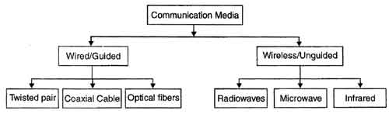](http://ecomputernotes.com/images/Types-of-Transmission-Media.jpg)

***Coaxial Cable***

Single copper conductor in the center surrounded by a plastic layer for insulation and a braided metal outer shield

***Twisted pair***

Four pairs of wires twisted to certain specifications. Available in shielded and unshielded versions.

***Fiber-optic –***

A cable, consisting of a center glass core surrounded by layers of plastic, that transmits data using light rather than electricity.

***Atmosphere/Wireless***

Uses Electromagnetic waves. whose frequency range is above that of microwaves, but below that of the visible spectrum.

***Choose Media based on :***

# Wiring configurations

# Distance and location limitations

# Speed

# Reliability

# Security

# Budget

**Network Devices**

Network devices / hardware may also be known as network equipment, computer networking devices. Units which are the last receiver or generate data are called [hosts](http://en.wikipedia.org/wiki/Host_%28network%29) or [data terminal equipment](http://en.wikipedia.org/wiki/Data_terminal_equipment).

All these terms refer to devices facilitating the use of a [computer network](http://en.wikipedia.org/wiki/Computer_network). Specifically, they mediate [data](http://en.wikipedia.org/wiki/Data) in a computer network.

There are number of network devices few of them are as follows:

## *Routers*

A router is a network device that connects together two or more networks.

A common use of a router is to join a home or business network (LAN) to the Internet (WAN).   
  
The router will typically have the Internet cable plugged into it, as well as a cable, or cables to computers on the LAN.

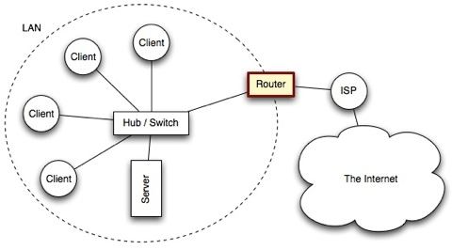

Alternatively, the LAN connection might be wireless (WiFi), making the device a wireless router. (A wireless router is actually a router and wireless switch combined)

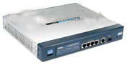

Routers work at the network layer (layer 3) of the Open Systems Interconnection (OSI) reference model for networking to move packets between networks using their logical addresses (which, in the case of TCP/IP, are the IP addresses of destination hosts on the network). Because routers operate at a higher OSI level than bridges do, they have better packet-routing and filtering capabilities and greater processing power, which results in routers costing more than bridges.

A router is a network device that **connects** together **two or more networks**.  
A common use of a router is to **join** a home or business network (**LAN**) to the **Internet** (WAN).   
  
The router will typically have the Internet cable plugged into it, as well as a cable, or cables to

## *HUB*

Networks using a Star topology require a central point for the devices to connect. Originally this device was called a concentrator since it consolidated the cable runs from all network devices. The basic form of concentrator is the hub.

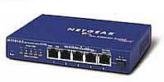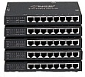

As shown in Figure; the hub is a hardware device that contains multiple, independent ports that match the cable type of the network. Most common hubs interconnect Category 3 or 5 twisted-pair cable with RJ-45 ends, although Coax BNC and Fiber Optic BNC hubs also exist. The hub is considered the least common denominator in device concentrators. Hubs offer an inexpensive option for transporting data between devices, but hubs don't offer any form of intelligence. Hubs can be active or passive.

An **active hub** strengthens and regenerates the incoming signals before sending the data on to its destination.

**Passive hubs** do nothing with the signal.

## *Switches*

Switches are a special type of hub that offers an additional layer of intelligence to basic, physical-layer repeater hubs. A switch must be able to read the MAC address of each frame it receives. This information allows switches to repeat incoming data frames only to the computer or computers to which a frame is addressed. This speeds up the network and reduces congestion.

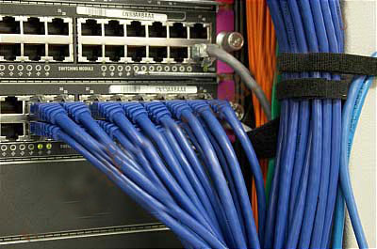

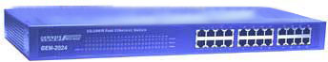

**Switches operate at both the physical layer and the data link layer of the OSI Model.**

## *Bridges*

A bridge is a network device that typically **links** together **two different parts of a LAN**.

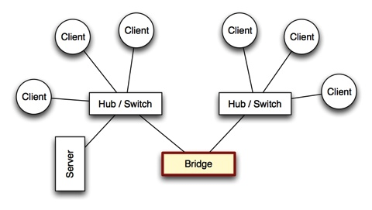

Whereas a router is usually used to link a LAN to a WAN (such as the Internet), a bridge links independent parts of a LAN so that they act as a single LAN.

A bridge is used to join two network segments together, it allows computers on either segment to access resources on the other. They can also be used to divide large networks into smaller segments. Bridges have all the features of repeaters, but can have more nodes, and since the network is divided, there is fewer computers competing for resources on each segment thus improving network performance.

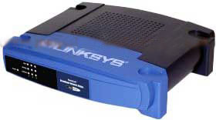

Bridges can also connect networks that run at different speeds, different topologies, or different protocols. But they cannot, join an Ethernet segment with a Token Ring segment, because these use different networking standards. Bridges operate at both the Physical Layer and the MAC sublayer of the Data Link layer. Bridges read the MAC header of each frame to determine on which side of the bridge the destination device is located, the bridge then repeats the transmission to the segment where the device is located.

***Network Interface Card (NIC)***

Any computer that is to be connected to a network, needs to have a network interface card(NIC).  
  
Most modern computers have these devices built into the motherboard, but in some computers you have to add an extra expansion card (small circuitboard)

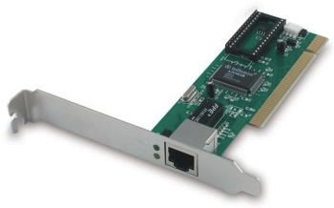

## *Modem*

Before the days of broadband Internet connections, most computers connected to the Internet via telephone lines (dial-up connections).   
  
The problem with using telephone lines is that they are designed to carry voices, which are [analogue](http://www.igcseict.info/theory/5/anadig/index.html) signals. They are not designed for digital data.

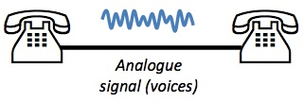

The solution was to use a special device to join the digital computer to the analogue telephone line. This device is known as a modem.